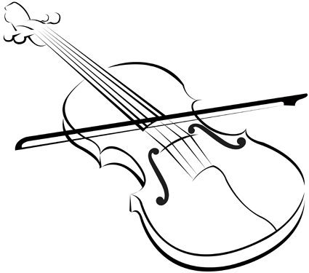
ATTENTION 5th GRADE STUDENTS!
Register Now for Strings Class

We want our strings program to continue being one of the best; therefore, we need the best students. We need your child!!
Participation in orchestra . . .
- Develops social skills and the ability to work with others.
- Improves communication.
- Develops mental and physical coordination
- Develops self-confidence, and a sense of accomplishment.
- Develops responsibility and self-discipline.
- Develops learning skills needed for success in every other academic subject.

Dear Fifth Grade Parents:
Your child has the opportunity to be a part of one of the most valued activities promoted by the Germantown Municipal School District. String instruction is available to all students in the district, and now starting in the fifth grade, violin, viola, cello, and bass instruction will be offered. This is a beginning strings course that will meet during the school hours.
This letter is for you because you play a vital part in making the decision regarding your child’s participation in this program. We hope you will discuss the program with your child as he/she learns about participating in strings class. More specific information regarding enrollment will be sent home with your child later, but this opportunity will be a great jump-start to middle school orchestra.
We urge you to carefully consider the enrollment of your child in strings class, for it may lead to educational possibilities for your child that might otherwise remain undeveloped. There is a growing body of research that shows that studying music in school is of tremendous benefit to every child, and we are eager for your child to begin to experience those benefits as well.
Thank you for considering string instruction for your child; I look forward to answering any questions you may have about the strings class and orchestra program in Germantown Municipal School District.

REGISTRATION FORM

If you would like for your child to participate in the 5th grade strings class next year please fill out the form. Please DO NOT OBTAIN AN INSTRUMENT AT THIS TIME; when classes begin, I will be sizing students for instruments. For your convenience, rental meetings will be held 8/15 at Riverdale Elementary and 8/28 at Dogwood Elementary. There will be a $100 strings fee for all other music materials for the year. If you have any questions concerning this class, please feel free to email me at any time.
Anthony Smith, Strings Class Instructor, anthony.smith@gmsdk12.org
________________________________________________________________

PLEASE RETURN TO YOUR HOMEROOM TEACHER

_____ I would like my child to enroll in strings this school year.
My preferred instrument of choice is violin, viola, cello, bass (circle one).

Student's Name ______________________

School _____________________________

Parents' Names __________________________________

Address ________________________________________

Phone ____________________________

Email _________________________________________________________

